Part 3: Questions

Pack Mules

1. Since the Golf Greens engine is being developed as a top-down 2D mini-putt game, it will be significantly harder to develop maps which have differing height levels. While it is still possible, there will be difficulties in envisioning the 3D aspect of it and implementing that into the game. With the addition of height, gravity will have to be added to each object, and a new value will have to take into account the height axis (x, y) 🡪 (x, y, z).
2. Another game the Golf Greens engine could easily be adapted into would be Pool/Pocket Billiards. With the physics-based parameters and collision already implemented, turning Golf Greens into a pool game would be a simple matter of placing multiple holes (6) at each corner and the center, and having movable objects to act as the balls.

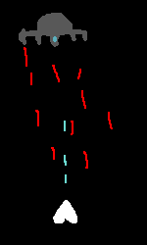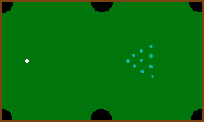

A different genre that could be hosted by our engine would be BulletHell/SpaceShip genre. Once again, because we have velocity and collision already implemented, choosing this genre instead would have a smoother transition as some of the core features are already coded in.

A new control system would have to be developed for the player. Previously we would have used click and drag for determining the direction of the ball. In this case, the controls would either be click and hold to move the player ship, or press either side of the screen to move the player ship in that direction.

A manager script is needed to keep track of the enemies and projectiles is required in order to prevent the generation of too many objects. It would make sure that the projectiles that leave the screen are removed so as to prevent ‘lagging’ of the main game. It will also keep track of the player’s score and display the UI for the player.

Finally, all actors (ships) would require several parameters – health, speed, armour – and so forth in order to calculate their destruction and interaction with each other.